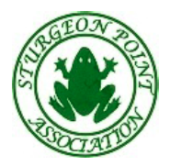
Sturgeon Point Association
Annual General Meeting

August 31, 2015 at 12:30 pm
Sturgeon Point Union Church

Agenda

- Approval of Minutes of AGM August 30, 2014 – Phil Robertson

- Trustee Report – Phil Robertson

- Directors Reports:
- Review & Approval of Financial Statements (2014 YE & 2015 YTD) – Bob LeCraw
- Playground Update – Bob LeCraw
- Social Report – Judy Haverkort
- Communications Report – Jacqui Mutch
- Roads and Maintenance Report – Jim Milford
- Upper Wharf Committee – Trevor Biasi
- President’s Report – Phil Robertson

- Election of New Members – Phil Robertson

- Other Business – Phil Robertson

We encourage all community members to attend and participate!

