SPA Communications Report – 2017 AGM
September 3, 2017
Report by: Jacqui Mutch-Potporksi – Communications Portfolio
Reaching New Sturgeon Pointers
- The “Welcome to Sturgeon Point” 3-page info piece was developed to provide newcomers with info about the Point and SPA. In June various Board members reached out with this info. Specifically like to thank Judy, Phil and Bob for their efforts.
- There is also a “Why SPA” document on the site explaining about the trust lands etc.
The SPA Website & Social Media
- SPA website continues to be the main source of communication with linkages to SLSC, the golf course websites. The church continues to host their info on the SPA site.
- SPA pages expanded this year to include a Safety area. Info about firebans, bike safety and bears.
- Posts on the SPA site are automatically updated on Facebook (at least they were until about a month ago when it stopped working). Jamie Wisener is investigating. Those posts are made manually now until things are resolved.
  - David Lightbound was been kind enough to post a notice on Facebook about the bears when I was out of the country.
- Our payments are processed through PayPal. We had some issues ensuring the “donations” button was coded for 2017 donations. Bob LeCraw was able to sort that out.
- Webstats – each month Jamie sends an analytics reports with details about the status of the site and some general analytics.
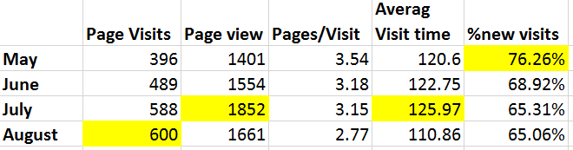

Email Communications
- Email communications are handled through a mail service called MailChimp which allow users to unsubscribe if need be. They can also subscribe as needed.
- We have 263 subscribers on the SPA distribution list. Three have unsubscribed this year.
- As a result of feedback last year, a webpage has been set up (under the “contact us” tab) with links to subscribe to the SPA email list, SLSC and golf course email lists.
- We have had 4 main email communications over the summer, with the July 2017 income statement – letter from President Phil Robertson (see Appendix A below) being the one that was opened the most.
- As a result Phil’s appeal, there was a flurry of SPA membership payment and donations. New emails as well. These new emails are being updated on our mailing list.*Donations up $10K
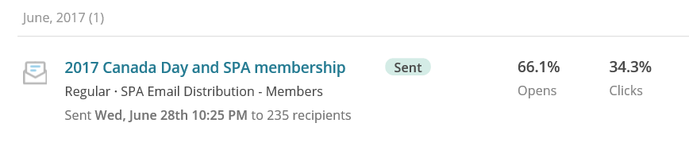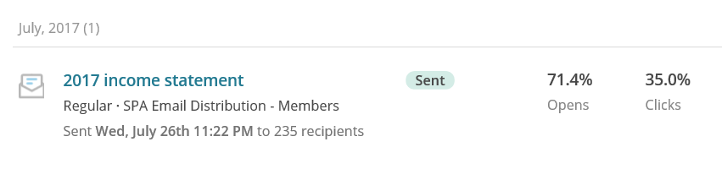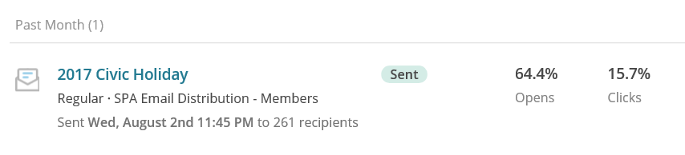
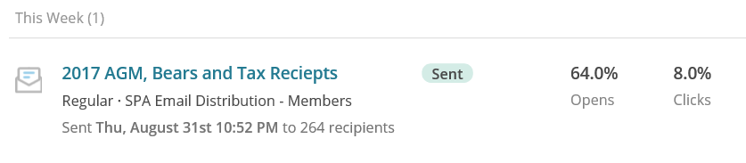
Action item: Question about advance notice of communications. Why don’t we get it sooner than the Thursday before the weekend. Response: Email communications are based on a collection of info from a variety of sources. The website is updated first and then the email communication is updated with links to the site. Attempt to send email communication sooner.

Appendix: Email communication July 2017

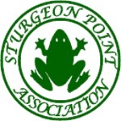July 2017 Income Statement
STURGEON POINT ASSOCIATION
July 2017
Dear members,
The Sturgeon Point Association Board feels that it is important that we keep all SPA members aware of how your membership money is used and how the recent ice damage to the upper wharf and public swimming dock has put SPA in a very difficult financial position.
The SPA membership fee of $40.00 for every member of the household age 18 and over has not changed in the past 5 years. Up until three years ago the association paid all the maintenance expenses for the park, leaf dump and swimming docks plus all our social events and was still able to accumulate about $10,000 in reserves.
Three years ago, our good luck ended. First the ice seriously damaged the concrete skirt at the front of the upper wharf and we had to have steel beams installed to protect swimmers from being washed under the dock. Last winter, the beams needed to be welded to stop them from banging together.
This past spring, the public swimming dock was damaged by ice and will require immediate cosmetic repair for the safety of swimmers and a more permanent repair next winter and the raft is in poor condition and in need of replacement. There is also dock deterioration on the west side of the upper wharf that needs to be repaired.
We may qualify for some 50/50 grants from the City of Kawartha Lakes, but these grants will not come until next year and we will need to pay the full amount and then recover the grant amount if we are successful.
Because of these recent and unexpected issues, SPA is in a difficult financial position. We just do not have the money to pay for all the required repairs. An outline of our typical income and expenses along with some estimates for the unusual expenses is attached for your review.
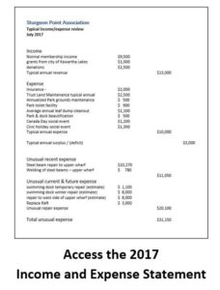
We are asking the SPA membership to assist us by making a generous donation in addition to your 2017 membership dues or we will not be able to make some of these needed dock repairs.
Your assistance is needed and would be greatly appreciated.
On behalf of the Sturgeon Point Association Board of Directors
Phil Robertson, President

